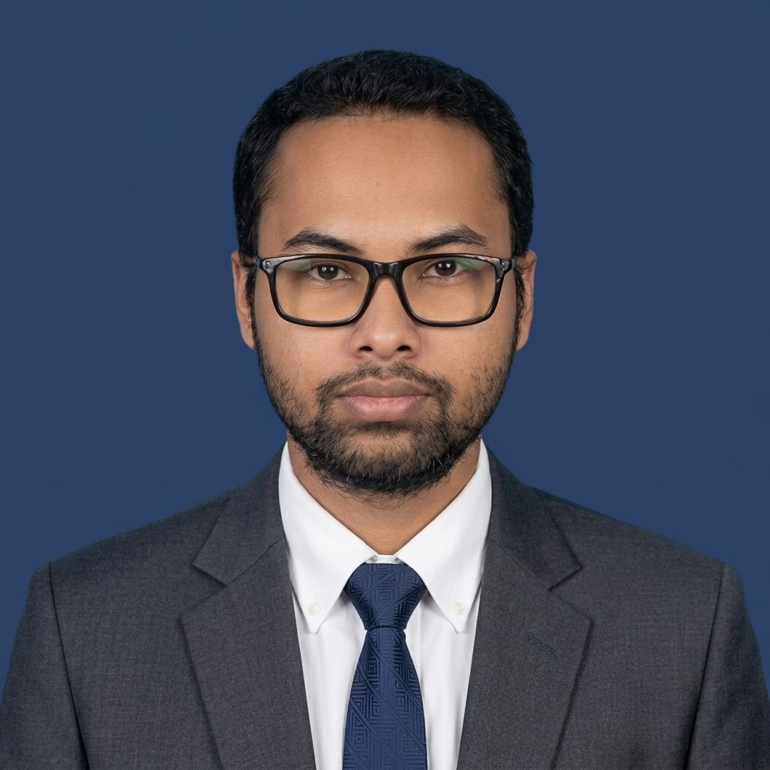 | MAHADI AL MOKTADIR  Special Correspondent & Multimedia Journalist
Official Emails: mahadi.sc@csbnewsusa.org | mahadi.csb@frosnews.org
Personal: mahadialmoktadir@gmail.com | Phone: +8801799594916 | Blood Group: O+ (O Positive)
Mother Company & Portals: CSB NEWS USA LLC (A Communication Satellite Broadcast) - frosnews.org • csbnews.us
New York Corporate Office: 166-41 88th Avenue, Jamaica, NY 11433, United States
Social Networks: LinkedIn • X (Twitter) • Facebook

Professional Summary
Current Role: Special Correspondent and Multimedia Broadcast Journalist with CSB NEWS USA LLC, currently delivering on-ground international reporting, investigative documentary features, live field coverage, and bilingual broadcast narration for FROS News World and FROS News বাংলা.
Bachelor of Education (B.Ed. Honours): Completed at the Institute of Education and Research (IER), University of Dhaka.
Master of Education (M.Ed.): Currently pursuing at the Institute of Education and Research (IER), University of Dhaka, with a specialization in Pre-Primary & Primary Education.
Professional Strengths: Field broadcasting, investigative storytelling, documentary production, post-production design, cross-platform multimedia workflows, and AI-assisted media production.
Core Technical Competencies & Skills
Broadcast & Field Journalism
Special Correspondent Reporting, On-Ground Live TV Broadcast, Fluent Bilingual Voiceover (English & Bangla), Broadcast News Narrator, Investigative Documentary Production, Scriptwriting & Direction, Live Field Moderation.

Core Technical Competencies & Skills
Video & Visual Post-Production  DaVinci Resolve, CapCut, Canva, Adobe Photoshop, Adobe Lightroom, Broadcast Color Grading, Graphic Design & Media Branding. | Research, Analytics & Tools  Microsoft Word, Microsoft PowerPoint, Basic SPSS Analytics, AI Prompt Engineering, Generative AI Photo/Video Creation.

Education & Policy Specialization  Pre-Primary & Primary Education Policy & Curriculum Analysis, English Version Elementary Pedagogy. | Acoustic Arts & Creative Performance  Solo Singing with Acoustic, Playing Guitar, Ukulele, Keyboard, Travel & Documentary Photography.

Languages
Bangla (Native Fluency), English (CEFR B2 Professional Working Proficiency).

Broadcast & Professional Journalism Experience
Special Correspondent / বিশেষ প্রতিনিধি — FROS NEWS WORLD & FROS NEWS বাংলা
April 2026 – Present (Promoted Freelance Journalist; Contract Valid till Dec 2028)
 frosnews.org  @FrosNews  @FROSNEWS  FROSNEWS  @fros_news_world
 @frosnewsworld  frosnewsbangla  @fros.news @fros.news1
• Direct and deliver investigative broadcast reports, national political dispatches, and on-camera live television coverage for international and diaspora audiences across YouTube, Facebook, TikTok, Truth Social, X, Instagram, and Threads.
• Lead end-to-end production of long-form documentaries: scriptwriting, investigative field inquiries, directing, and audio-visual post-production.
• Provide broadcast-standard news narration and fluent voiceovers in both English and Bangla for global bulletins.
• Implement cutting-edge AI prompt engineering and generative media synthesis to accelerate broadcast motion graphics and concept visualizers.
• Manage cross-platform multimedia transmission, optimizing high-resolution video streams across satellite, web, and social networks.
Multimedia Correspondent / Editor & Dhaka University Correspondent — CSB NEWS USA LLC
June 2025 – August 2026 (Joined June 2025 as probationary DU Correspondent; Aug 2025 – Aug 2026 1-Year Contract Completed) | Portal: csbnews.us
• Spearheaded nationwide field reporting focusing on socio-political dynamics, governance, civic voices, and the Bangladesh National Election 2026.
• Conducted exclusive high-profile on-camera interviews with public intellectuals, civic leaders, university scholars, and international observers.
• Provided live television field updates, breaking news broadcasts, and rapid digital video editing under demanding deadlines.
Intern Elementary Teacher (English Version) & Academic Content Developer — University Laboratory School & College, Dhaka
July 2023 – December 2023 | Institute of Education and Research (IER), University of Dhaka
• Taught diverse subjects to pre-primary and primary elementary students in English Version, designing innovative lesson plans, visual aids, and experiential learning modules.
• Administered student academic documentation, continuous assessments, and integrated multimedia resources to elevate classroom participation.
Academic Qualifications
Master of Education (M.Ed.) - Pre-Primary & Primary Education (Policy & Curriculum)  Institute of Education and Research (IER), University of Dhaka | Pursuing | Expected completion: End of 2026 | Bachelor of Education (B.Ed. Honours)  Institute of Education and Research (IER), University of Dhaka | Completed | Session: 2019-2024
Higher Secondary Certificate (HSC) — Science  Dhaka City College | Passing Year: 2018 | Secondary School Certificate (SSC) — Science  Ideal High School and College | Passing Year: 2016

Featured Documentaries & Video Reports (With Direct Links)
1 | DUCSU Election 2025: In-Depth Documentary (World Audience)  In-depth investigative documentary exploring Dhaka University student politics, youth democratic aspirations, and the historic DUCSU election.  Direct Watch Link: https://youtu.be/Fv5Jxe_uod0?si=DHQWruhBxrmBIJf_

2 | The Chittagong Hill Tracts — The Untold Story of the Hills (World Audience)  On-location visual feature and investigative documentary highlighting indigenous culture, biodiversity, and regional socio-political realities.  Direct Watch Link: https://www.instagram.com/reel/DVRFPgnChl7/?utm_source=ig_web_button_share_sheet

3 | ভোটের মাধ্যমে ভবিষ্যৎ নির্ধারণ—বাংলাদেশের জনগণ কী চায় ২০২৬ নির্বাচনে? (National Audience)  Grassroots political documentary analyzing voter aspirations, democratic reform demands, and public sentiment for the 2026 National Election.  Direct Watch Link: https://www.facebook.com/share/v/1CZFBGJHWz/

4 | বাংলাদেশ জাতীয় সংসদ নির্বাচন ২০২৬: প্রত্যাশা, প্রতিশ্রুতি ও রাজনৈতিক বাস্তবতা (National Audience)  Comprehensive broadcast analysis exploring political party manifestos, socio-economic challenges, and electoral ground reality.  Direct Watch Link: https://www.facebook.com/share/v/1FN7fMViYa/

Projects & Co-Curricular Involvements  • IERDC 50-50 Debate Competition (July 2022) — Content Supervisor: Evaluated debate motions, verified factual accuracy of competition materials, and established judging guidelines for inter-university debaters.  • Research & Publication Fair (October 2023) — Organizer: Coordinated logistics, publisher delegations, and vendor management for Bangladesh's historic first university research fair at the University of Dhaka.  • KIX Bangladesh Uptake Forum (January 2024) — Cultural Wing Assistant: Managed cultural logistics for international educational delegates and performed as an invited musical artist during the formal sessions.  • Dhaka University Research Society (DURS): Recreational Secretary (2022 – 2023).  • Dhaka University Band Society (DUBS): Executive Member (2019 – 2022).  • Plasma Bank BD: Founding Member (2019 – 2020). | Reference
  Prof. Dr. Jasim Uddain
  Pro-Vice Chancellor, Z. H. Sikder University of Science and Technology (ZHSUST)

Visual Media Portfolio & On-Ground Field Archive
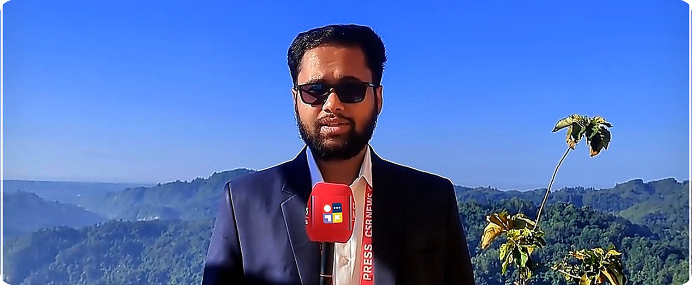

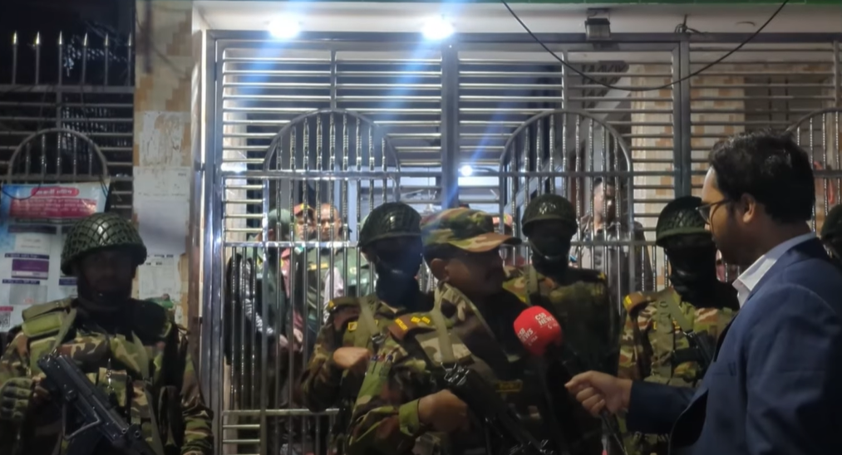 | 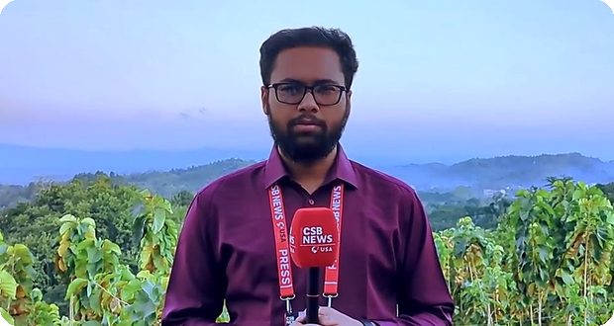 | 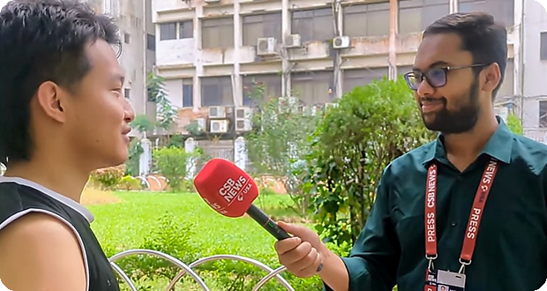

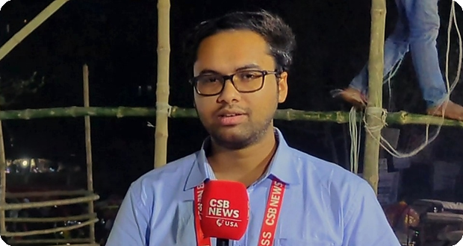 | 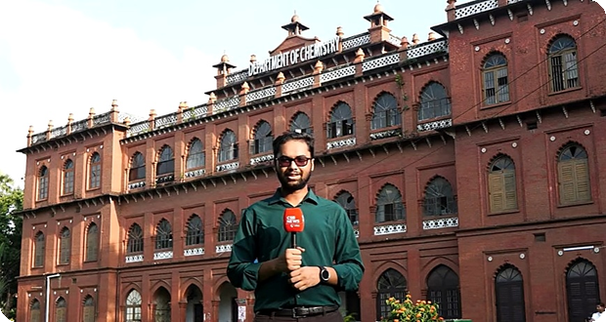 | 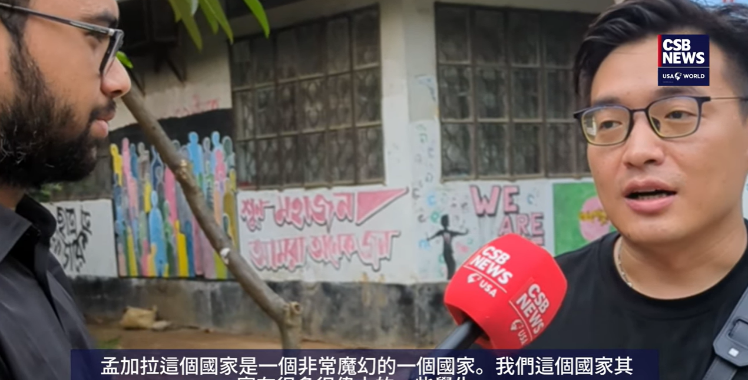

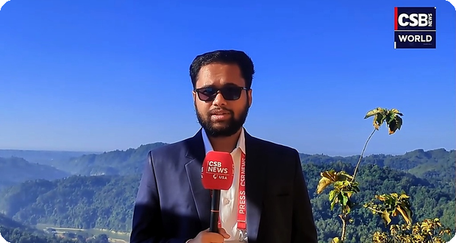 | 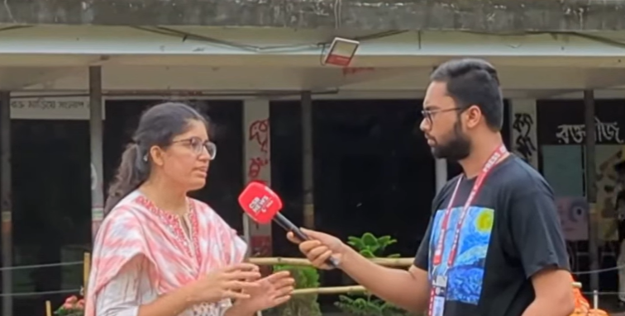 | 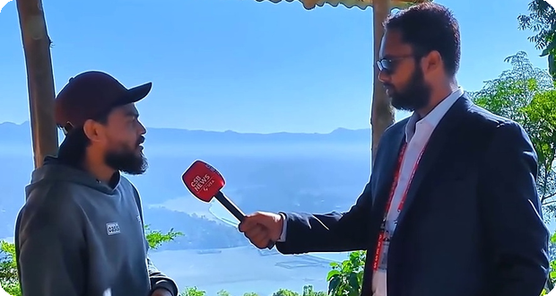

Corporate Credentials
Mother Organization: CSB NEWS USA LLC (A Communication Satellite Broadcast)  New York Corporate Office: 166-41 88th Avenue, Jamaica, NY 11433, United States  Contact & Email: +1 718-709-1533 | csbnewsusa.info@gmail.com  Bearer Status: Registered Media Representative & Special Correspondent authorized for on-ground news gathering.  Channels: FROS News World (frosnews.org) • FROS News বাংলা • CSB News USA (csbnews.us) |   SCAN TO VERIFY  This QR code opens the official FROS News website.  frosnews.org
  FROS News World  International & multimedia coverage | FROS News বাংলা  Bangla-language reporting | CSB News USA  Mother network portal

